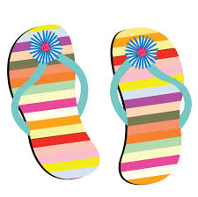
Flippin’ into Spring 2019
Session Schedule
Location: Mr. Todd’s Gymnastics, 12 Olympic Way, Poughkeepsie NY 12603

Friday, March 1, 2019
Session 1: Level 2 and Level 5 (all teams)
1:50pm Report Time; 2:00pm Warm-up; 2:30pm compete

Session 2: Xcel Silver (Small teams from: MTG, AAG, Cross Island, VeGa, Gym Cats, Infinity & JCC) 4:20pm Report Time; 4:30pm Warm-up; 5:00pm Compete

Session 3: Xcel Silver (Large teams from: Westchester, Ziggy’s, Dynamic & Odyssey) 7:05pm Report Time; 7:15pm Warm-up; 7:45pm Compete

Saturday, March 2, 2019
Session 4: Xcel Bronze (all teams)
7:50am Report Time; 8:00am Warm-up; 8:30am Compete

Session 5: Level 3 (all teams)
11:50am Report Time; 12:00pm Warm-up; 12:30pm Compete

Session 6: Xcel Gold (all teams)
3:50pm Report Time; 4:00pm Warm-up; 4:30pm Compete

Sunday, March 3, 2019
Session 7: Level 4 (all teams)
7:50am Report Time; 8:00am Warm-up; 8:30am Compete

Session 8: Platinum, Diamond, Level 8, Level 9 and Level 10 (all teams)
12:20pm Report Time; 12:30pm Warm-up; 1:00pm Compete

Session 9: Level 6 and Level 7 (all teams) & Platinum athletes from JCC
4:05pm Report Time; 4:15pm Warm-up; 4:45pm Compete

